ARTICLE TEMPLATE FOR AFRICAN – BRITISH JOURNALS
(Paper Size: A4; Margins – Top: 1”, Bottom: 1”, Left: 1” Right: 1”)
All texts must be single line spacing, including abstract and references. Text should be fully justified.
All Fonts are Times New Roman with Size=12

MAIN ARTICLE TITTLE
(Corresponding Author) John Smith
(Author Affiliation) Department of Economics, Faculty of Management, University of Florida.
E-mail: email @gmail.com

(Co-Author Name) Ali Mohammed
(Co-Author Affiliation) Department of Economics, Faculty of Management, University of Florida.

ABSTRACT (The abstract may be up to 150 words in length)
The paper should have an abstract. The abstract should be understandable by the general reader outside the context of the full paper.

KEYWORDS: Keyword1, Keyword2, Keyword3, (Max. 7 words)

ARTICLE STRUCTURE

INTRODUCTION

LITERATURE/THEORETICAL UNDERPINNING

METHODOLOGY

RESULTS/FINDINGS

DISCUSSION

IMPLICATION TO RESEARCH AND PRACTICE

CONCLUSION

FUTURE RESEARCH

REFERENCES

FIGURES
The figures in your article should be titled like the example shows below:

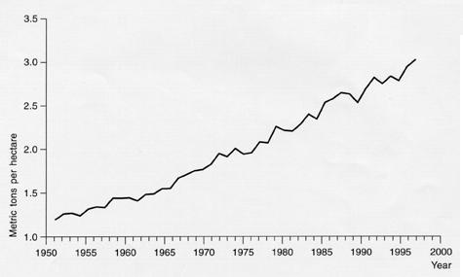
Figure 1: The title should always be placed below the figure.

TABLES
Tables should be titled like the example shows below:

Table 1: The title should always be placed above the table
Question | Average | Means
1. NGOs | 11 | 1.1
2. Institutions | 22 | 2.2
3. Governments | 33 | 3.3

REFERENCES (References should follow APA Referencing Style)
Barnard, R., de Luca, R., & Li, J. (2016). First-year undergraduate students’ perceptions of lecturer and peer feedback: A New Zealand action research project. Studies In Higher Education, 40(5), 933–944. https://doi.org/10.1080/03075079.2016
Easton, B. (2012). Does poverty affect health? In K. Dew & A. Matheson (Eds.), Understanding health inequalities in Aotearoa New Zealand (pp. 97–106). Dunedin, New Zealand: Otago University Press.
Li, S., & Seale, C. (2007). Learning to do qualitative data analysis: An observational study of doctoral work. Qualitative Health Research, 17(10), 1442-1452. https://doi.org/10.1177/1049732307306924
Rush, E. C., Obolonkin, V., Battin, M., Wouldes, T., & Rowan, J. (2015). Body composition in offspring of New Zealand women: Ethnic and gender differences at age 1–3 years in 2005–2009. Annals Of Human Biology, 42(5), 492–497.
Rush, E., McLennan, S., Obolonkin, V., Cooper, R., & Hamlin, M. (2015). Beyond the randomised controlled trial and BMI--evaluation of effectiveness of through-school nutrition and physical activity programmes. Public Health Nutrition, 18(9), 1578–1581. https://doi.org/10.1017/S1368980014003322

